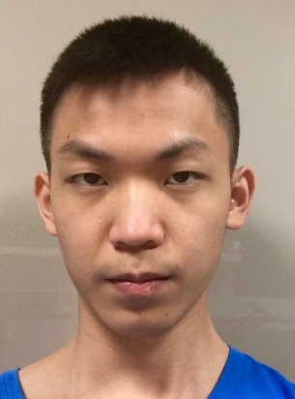

* (2015-2016): Undergraduate 1st and 2nd Year of BSc Computer Science at The University of Sheffield
* (2014-2015): Sheffield International College (SIC)
* (2012-2014): Guigang Senior High School in Guangxi, China

Education

Personal Detail

Phone Number:07340241601

Personal Email Address: [1099404025@qq.com](mailto:1099404025@qq.com)

University Email Address: [jchen54@sheffield.ac.uk](mailto:jchen54@sheffield.ac.uk)

Current Address:

Studio 528, Vita Student, Telephone House, 40 Charter Square, Sheffield

S11BA

Junjin Chen

**Description about my study**

**English**: Not native, but it is good enough. I got 60 in average (out of 100) in the college, there may be some improvement for now.

**Math**: I have been keeping a good grade in math since I was in my primary school. In the Computer Science department, I learned a lot about the logic and matrix, which help me in coding and graphic transforming design. Well there may be some balance between my math and communication skill unfortunately. (Sometimes my logic does not fit in to others but I can deal with that, trust me.)

**Programming languages**: I learned basic thing in programming languages, such as inheritance, polymorphism, IO etc. I achieved the ant robot coding competition using java, it was to make the robot follow a specific path to ‘home’. I cooperated with my colleagues and made a dental system in Java. I made a Sokoban game in Ruby. And in a group I made a twitter app which serves for a restaurant using ruby. On my own I wrote a website with some games on it using the Php (and javascript, css, mysqlite).

Birthday: 2nd March 1997

Sex: Male

Nationality: Chinese

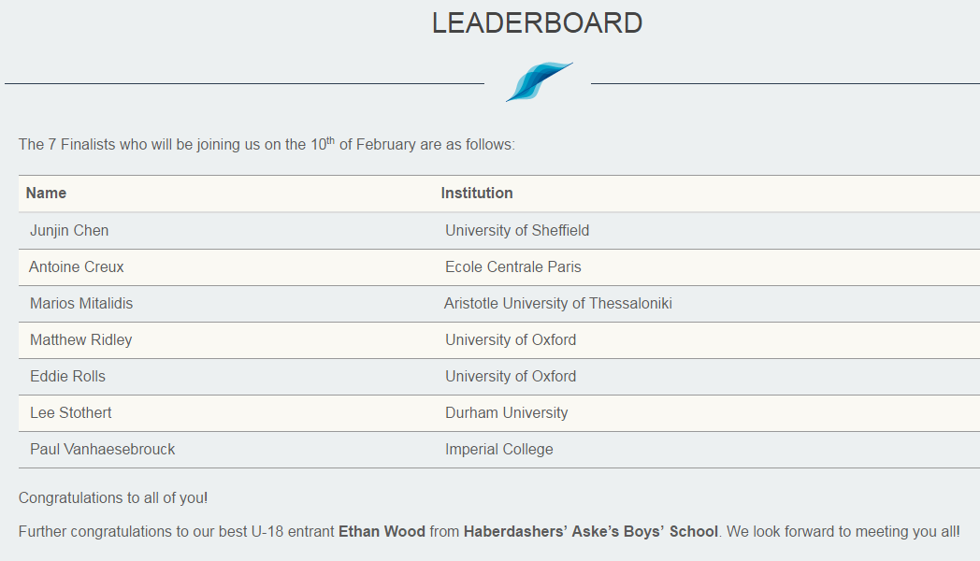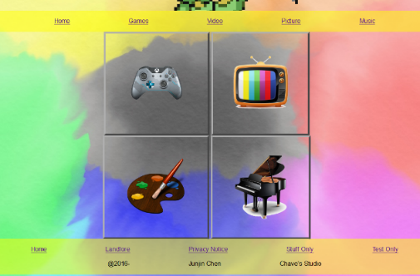

Achievement

* Social Innovation Lab
  + Creativity, Management Skill, Teamwork Ability, Speech Skill.
* Examination condition filming volunteer
  + Performance Skill
* 24 hours inspiration volunteer (Selling tickets and raising money for those who suffer from cancer)
  + Sales Skill
* 30 hours gameJam (make a game with given theme in 30 hours)
  + Game design skill, Time-Management Skill
* Being a Mentor of 2 Mentees
  + Leading Skill
* Pair Coding competition
  + Pair Programming Skill
* Photoshop Lessons
  + Art Skill
* Top 7 in Man AHL Coder Prize
  + Being Smart☺

And I would like to publish it after it is good enough. I wrote a word search programme in python. On my own I made it top 7 in a coding competition which was to write an algorithm to play the game HiveMinder. (https://www.ahl.com/coderprize) I also learned a functional programming language named Haskell and I wrote a simulate enigma and the machine to break enigma using Haskell.

**AI** (artificial intelligence): I learned many algorithms for AI such as best_first (which was used in the coding competition by me), branch_and_bound, A* etc. I also learned data driven computing which is to make the machine learns from given data such as faces-learning, speaking-recognition etc.

**Software Engineering**: This module showed me how to manage a software manufacturing process, which method to be used to manage different software developing process, what problems are we facing when making a software, how to communicate with client and how to work with teammates and etc. I would like to see how it works in practice.